Triangular Decomposition

Definition
# Source: AI Source: Provided by: [Data Path: Persons Table -> ID Column: 1, Name_En Column: Motasem Essam] -> From: [ChatGPT] on [7/25/2026]
Triangular Decomposition is a type of geometric figure decomposition in which a larger geometric figure is divided into two or more triangular regions.
The divisions are typically created by drawing diagonals, connecting vertices to other vertices, or drawing segments from a vertex to a point on an opposite side. Triangular decomposition is especially useful for calculating areas, proving geometric theorems, and analyzing polygons.
Simple definition: Triangular decomposition is dividing a geometric figure into triangles to make it easier to study or measure.
Examples include:
- Dividing a rectangle into two triangles using a diagonal.
- Dividing a pentagon into three triangles.
- Dividing a polygon into triangles by connecting its vertices to one interior point.
- Dividing an irregular region into several triangular parts.

Main Classification
# Source: AI Source: Provided by: [Data Path: Persons Table -> ID Column: 1, Name_En Column: Motasem Essam] -> From: [ChatGPT] on [7/25/2026]
The following is a practical, descriptive classification, not a universally standardized mathematical taxonomy. Some categories overlap.

1. Diagonal-Based Triangular Decomposition
# Source: AI Source: Provided by: [Data Path: Persons Table -> ID Column: 1, Name_En Column: Motasem Essam] -> From: [ChatGPT] on [7/25/2026]
A polygon is divided into triangles by drawing one or more diagonals between its vertices.
Example: A rectangle divided into two triangles by one diagonal.
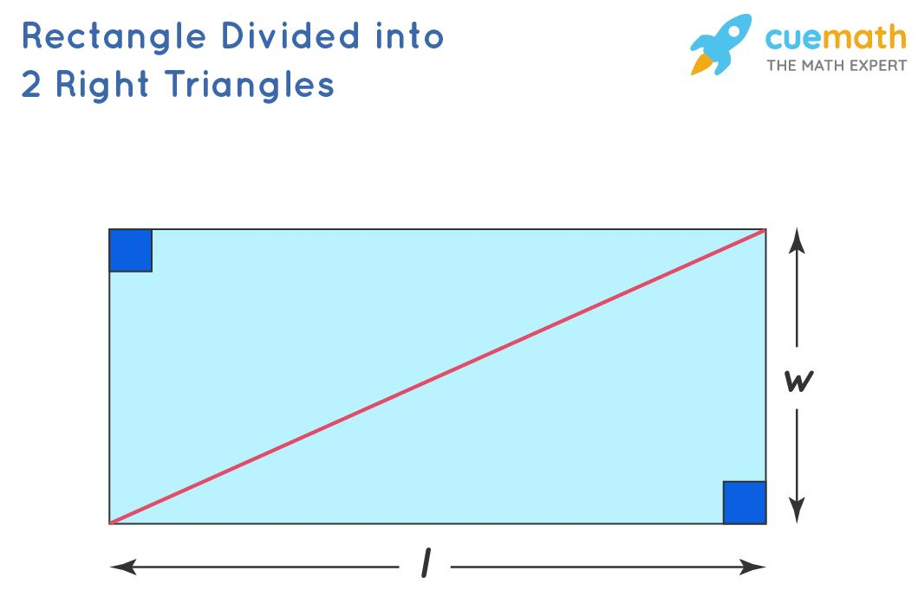
Detailed Explanation and Examples
Definition: A polygon is divided into triangular regions by drawing diagonals between its vertices.
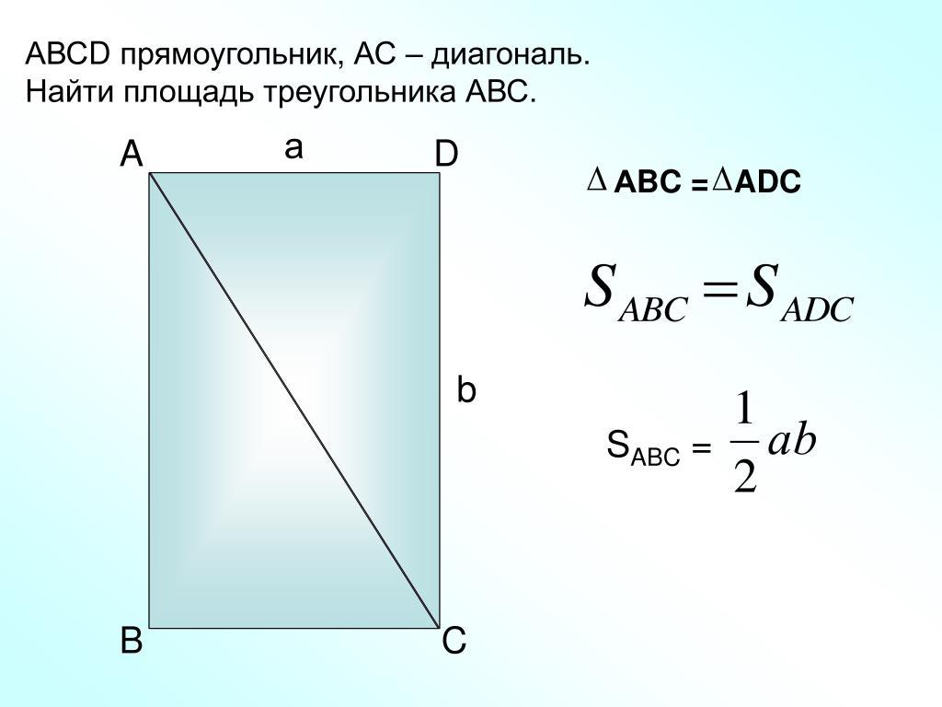
Example: Rectangle $ABCD$ has length $8$ units and width $5$ units. Diagonal $\overline{AC}$ divides it into two triangles.
Area of the rectangle:
$$A=8×5=40$$
Each triangle has half the rectangle's area:
$$A_{1}=A_{2}=\frac{12}{\left(8\right)}\left(5\right)=20$$
Therefore,
$$\boxed{A_{\text{total}}=20+20=40}$$
Key principle: A diagonal divides a rectangle into two equal-area triangles. More generally, a diagonal divides a convex polygon into two smaller polygons, which can then be triangulated.

2. Vertex-Based Triangular Decomposition
# Source: AI Source: Provided by: [Data Path: Persons Table -> ID Column: 1, Name_En Column: Motasem Essam] -> From: [ChatGPT] on [7/25/2026]
Diagonals are drawn from one vertex to all its nonadjacent vertices.
Example: A convex pentagon divided into three triangles.
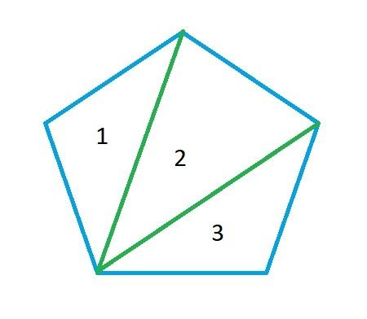
Detailed Explanation and Examples
Definition: One vertex of a polygon is connected to all its nonadjacent vertices, dividing the polygon into triangles.
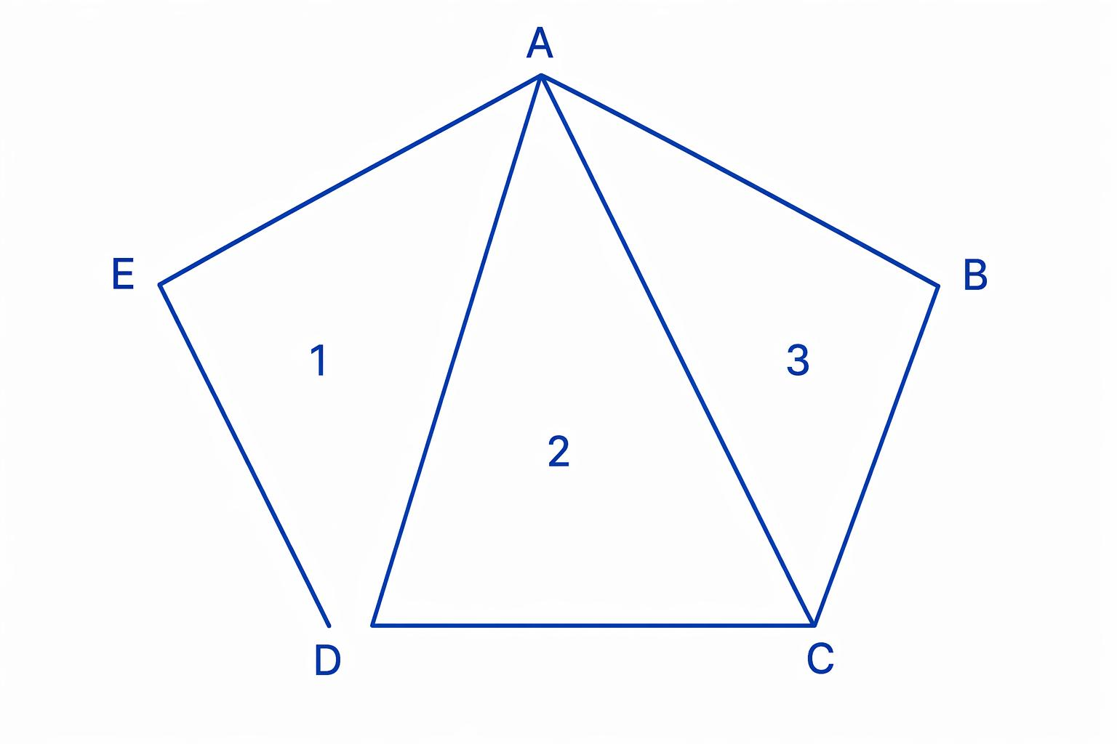
Example: A convex pentagon has five vertices. Drawing diagonals from one vertex to its two nonadjacent vertices creates three triangles.
For a convex polygon with $n$ vertices, the number of triangles in this decomposition is:
$$\boxed{T=n-2}$$
For a pentagon:
$$T=5-2=3$$
If the three triangles have areas $12$, $15$, and $18$ square units, then:
$$A_{\text{pentagon}}=12+15+18$$
$$\boxed{A_{\text{pentagon}}=45}$$
This method is useful for finding the area of polygons whose dimensions are easier to determine after triangulation.

3. Center-Based Triangular Decomposition
# Source: AI Source: Provided by: [Data Path: Persons Table -> ID Column: 1, Name_En Column: Motasem Essam] -> From: [ChatGPT] on [7/25/2026]
An interior point is connected to the vertices to create triangular regions.
Example: A convex hexagon divided into six triangles by connecting its center to all vertices.
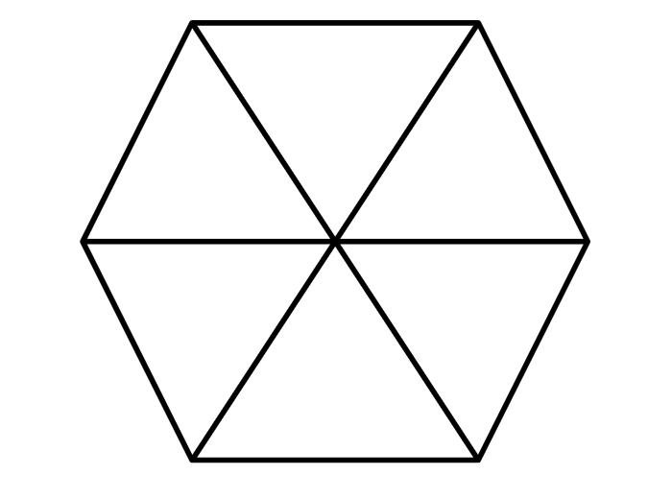
Detailed Explanation and Examples
Definition: An interior point is connected to the vertices of a polygon to divide the region into triangular sections.
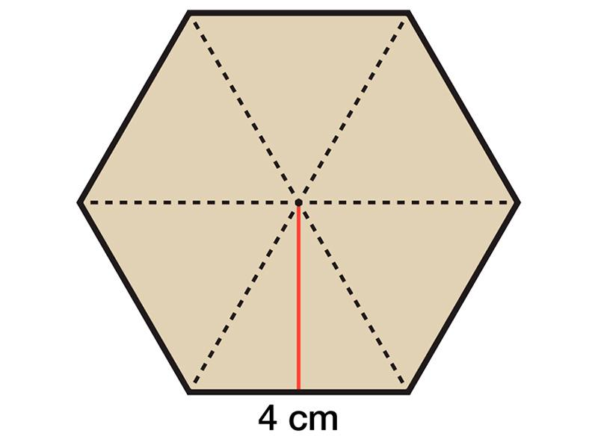
Example: A regular hexagon has side length $4$ units. Connecting its center to all six vertices creates six congruent equilateral triangles.
Each triangle has area:
$$A_{1}=\frac{\sqrt{3}}{4}{\left(4\right)}^{2}=4\sqrt{3}$$
The hexagon's total area is:
$$A=6\left(4\sqrt{3}\right)$$
$$\boxed{A=24\sqrt{3}}$$
Important: Connecting an interior point to all vertices divides a convex polygon into $n$ triangles. The triangles are not necessarily equal in area unless additional conditions hold. For a concave polygon, such connections may extend outside the polygon, so this method must be used carefully.

4. Cevian-Based Triangular Decomposition
# Source: AI Source: Provided by: [Data Path: Persons Table -> ID Column: 1, Name_En Column: Motasem Essam] -> From: [ChatGPT] on [7/25/2026]
Segments from triangle vertices to points on opposite sides divide a triangle into smaller triangular regions.
Example: A triangle divided by a median or multiple cevians.
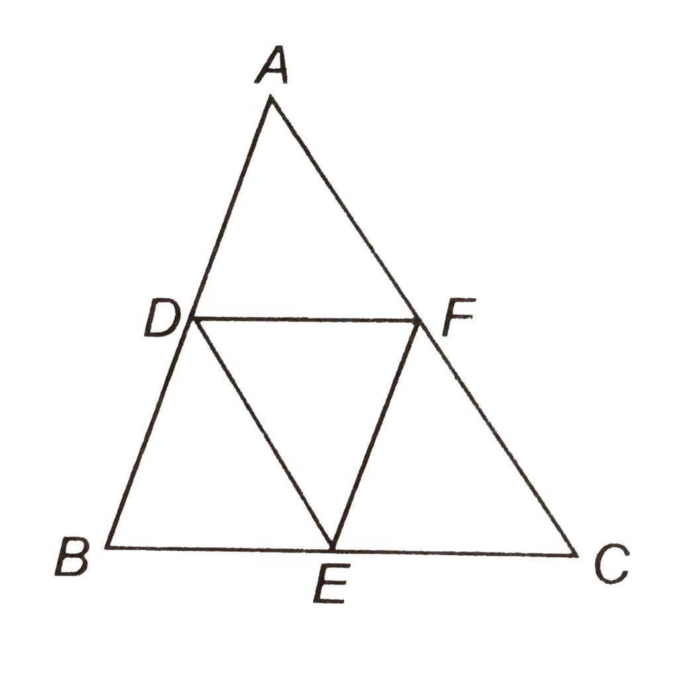
Detailed Explanation and Examples
Definition: A triangle is divided into smaller triangular regions by drawing cevians—segments from a vertex to a point on the opposite side or its supporting line.
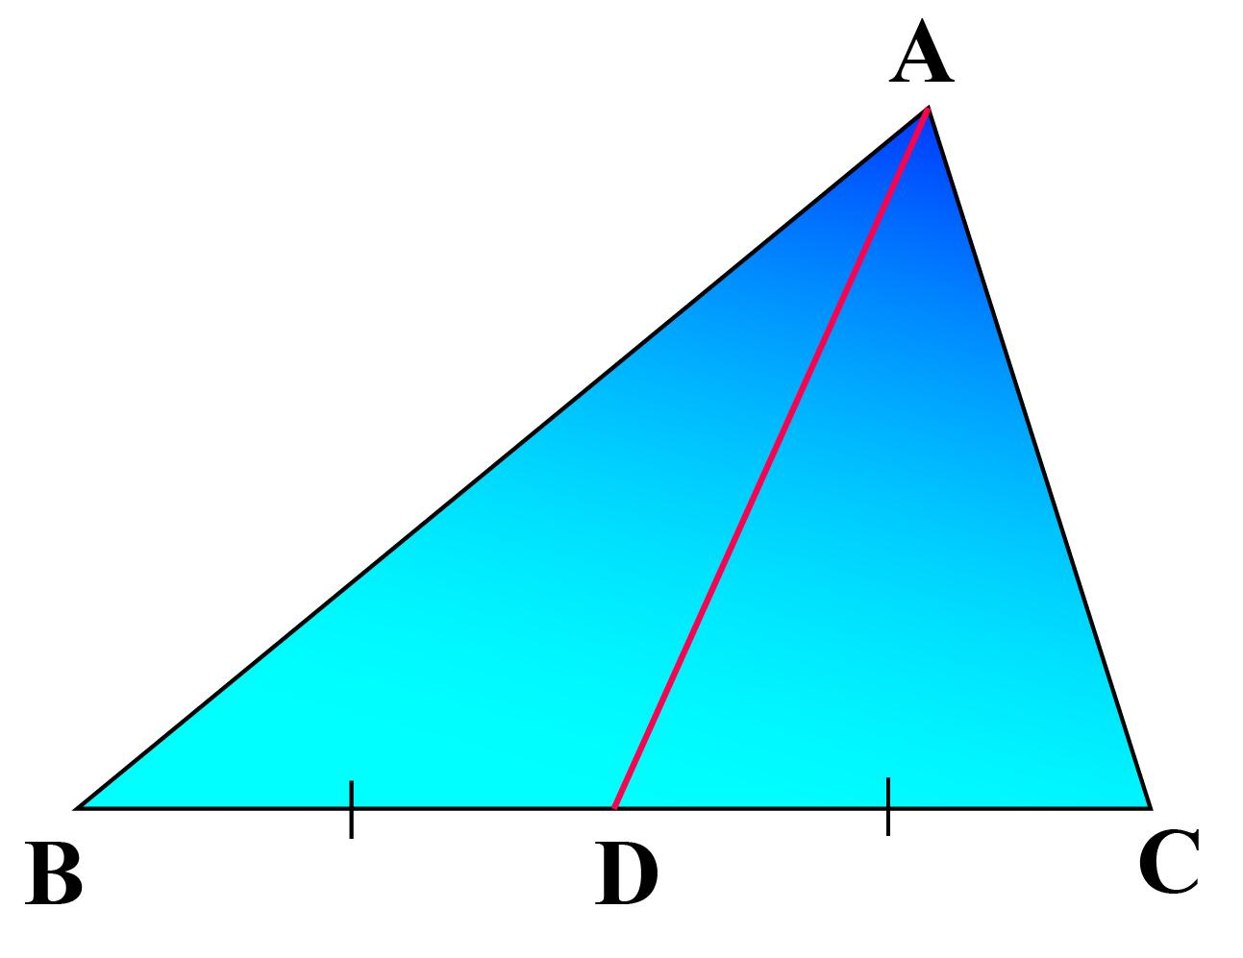
Example: Triangle $ABC$ has base $BC=10$ units and altitude $AH=6$ units. Median $AD$ meets $BC$ at its midpoint $D$, so $BD=DC=5$.
The total area is:
$$A_{ABC}=\frac{12}{\left(10\right)}\left(6\right)=30$$
Because the two smaller triangles share the same altitude to line $BC$ and have equal bases:
$$A_{ABD}=A_{ACD}=\frac{12}{\left(5\right)}\left(6\right)=15$$
Therefore,
$$\boxed{A_{ABD}=A_{ACD}=15}$$
Key principle: A median divides a triangle into two equal-area triangles. A general cevian does not necessarily divide the triangle into equal areas.

5. Irregular-Polygon Triangular Decomposition
# Source: AI Source: Provided by: [Data Path: Persons Table -> ID Column: 1, Name_En Column: Motasem Essam] -> From: [ChatGPT] on [7/25/2026]
An irregular polygon is partitioned into triangles, usually through a triangulation.
Example: A convex or suitable simple polygon divided into triangles.
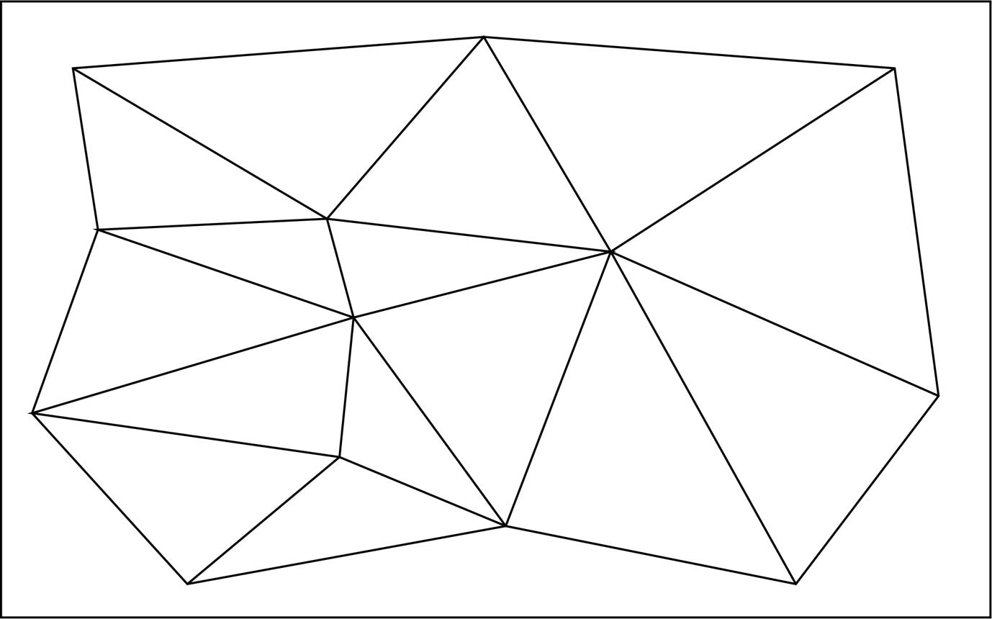
Detailed Explanation and Examples
Definition: A simple polygon with an irregular outline is divided into non-overlapping triangles using internal diagonals.
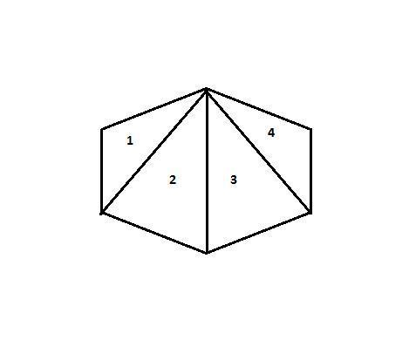
Example: A convex hexagon is triangulated from one vertex.
The number of triangles is:
$$T=6-2=4$$
Suppose the four triangle areas are $8$, $11$, $13$, and $16$ square units.
Then:
$$A_{\text{hexagon}}=8+11+13+16$$
$$\boxed{A_{\text{hexagon}}=48}$$
For a simple polygon with $n$ vertices, a triangulation into non-overlapping triangles uses exactly $n-2$ triangles, provided the polygon is treated as a single simple region without holes.

6. Multiple-Triangle Decomposition
# Source: AI Source: Provided by: [Data Path: Persons Table -> ID Column: 1, Name_En Column: Motasem Essam] -> From: [ChatGPT] on [7/25/2026]
A figure is divided into several triangles that may differ in size, shape, and orientation.
Example: A large triangular region partitioned into several smaller triangles.
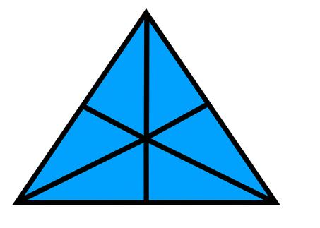
Detailed Explanation and Examples
Definition: A geometric region is divided into several triangular pieces by drawing multiple internal segments.
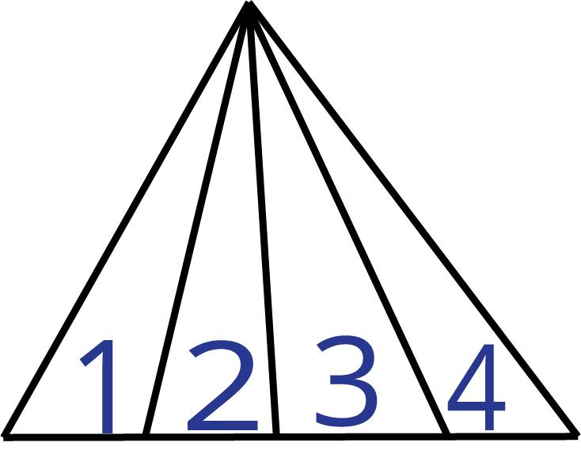
Example: Triangle $ABC$ has base $BC=12$ units and altitude $AH=5$ units. The base is divided into four equal segments of length $3$, and each division point is connected to $A$.
The total area is:
$$A_{ABC}=\frac{12}{\left(12\right)}\left(5\right)=30$$
Each smaller triangle has the same altitude and a base of $3$:
$$A_{\text{small}}=\frac{12}{\left(3\right)}\left(5\right)=7.5$$
Thus:
$$\boxed{A_{\text{total}}=4\left(7.5\right)=30}$$
This demonstrates how a figure can be decomposed into several triangles whose areas add up to the whole.

7. Concave-Polygon Triangular Decomposition
# Source: AI Source: Provided by: [Data Path: Persons Table -> ID Column: 1, Name_En Column: Motasem Essam] -> From: [ChatGPT] on [7/25/2026]
A concave polygon is divided into triangles using diagonals that remain inside the polygon.
Example: A concave pentagon triangulated into three triangles.
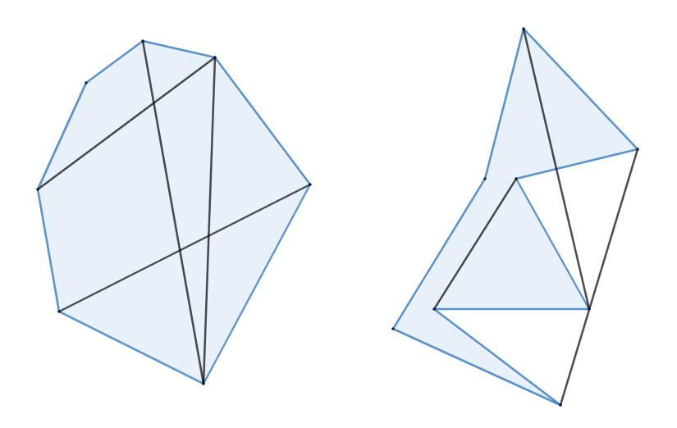
Detailed Explanation and Examples
Definition: A concave polygon is partitioned into triangles using diagonals that lie inside the polygon.
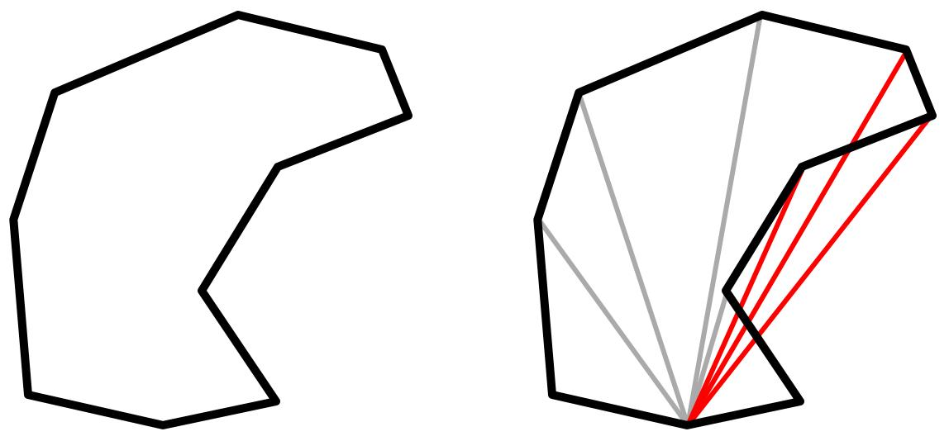
Example: A simple concave pentagon is divided into three non-overlapping triangles by drawing valid internal diagonals.
Since it has $n=5$ vertices:
$$T=n-2=5-2=3$$
If the three triangles have areas $9$, $7$, and $5$ square units, the total area is:
$$\boxed{A_{\text{polygon}}=9+7+5=21}$$
Important: For a concave polygon, not every diagonal lies inside the polygon. The selected diagonals must form a valid triangulation without leaving the region or creating overlapping interiors.

Important Formulas and Principles
# Source: AI Source: Provided by: [Data Path: Persons Table -> ID Column: 1, Name_En Column: Motasem Essam] -> From: [ChatGPT] on [7/25/2026]
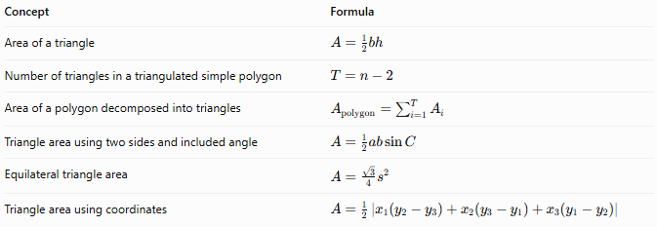
Concept | Formula
Area of a triangle | $$A=\frac{1}{2}bh$$
Number of triangles in a triangulated simple polygon | $$T=n-2$$
Area of a polygon decomposed into triangles | $$A_{\text{polygon}}=\sum_{i=1}^{T}{A_{i}}$$
Triangle area using two sides and included angle | $$A=\frac{1}{2}ab\sin{C}$$
Equilateral triangle area | $$A=\frac{\sqrt{3}}{4}s^{2}$$
Triangle area using coordinates | $$A=\frac{1}{2}\left|x_{1}\left(y_{2}-y_{3}\right)+x_{2}\left(y_{3}-y_{1}\right)+x_{3}\left(y_{1}-y_{2}\right)\right|$$
Here, $n$ is the number of vertices of a simple polygon, $T$ is the number of triangles, $b$ is a triangle's base, and $h$ is its corresponding perpendicular height.
Area principle:
$$\boxed{A_{\text{whole}}=\sum{A_{\text{triangles}}}}$$
This applies when the triangles cover the original region completely without gaps or overlapping interiors.

Triangular Decomposition vs. Related Concepts
# Source: AI Source: Provided by: [Data Path: Persons Table -> ID Column: 1, Name_En Column: Motasem Essam] -> From: [ChatGPT] on [7/25/2026]
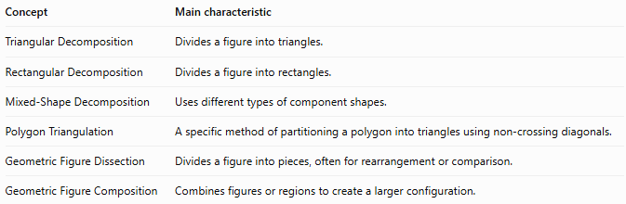
Concept | Main characteristic
Triangular Decomposition | Divides a figure into triangles.
Rectangular Decomposition | Divides a figure into rectangles.
Mixed-Shape Decomposition | Uses different types of component shapes.
Polygon Triangulation | A specific method of partitioning a polygon into triangles using non-crossing diagonals.
Geometric Figure Dissection | Divides a figure into pieces, often for rearrangement or comparison.
Geometric Figure Composition | Combines figures or regions to create a larger configuration.

Classification Summary
# Source: AI Source: Provided by: [Data Path: Persons Table -> ID Column: 1, Name_En Column: Motasem Essam] -> From: [ChatGPT] on [7/25/2026]
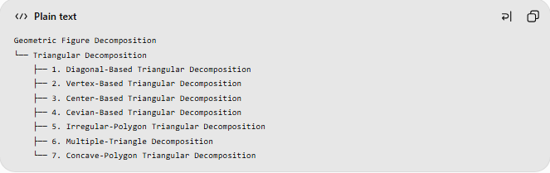
Geometric Figure Decomposition
└── Triangular Decomposition
├── 1. Diagonal-Based Triangular Decomposition
├── 2. Vertex-Based Triangular Decomposition
├── 3. Center-Based Triangular Decomposition
├── 4. Cevian-Based Triangular Decomposition
├── 5. Irregular-Polygon Triangular Decomposition
├── 6. Multiple-Triangle Decomposition
└── 7. Concave-Polygon Triangular Decomposition

Key Points
# Source: AI Source: Provided by: [Data Path: Persons Table -> ID Column: 1, Name_En Column: Motasem Essam] -> From: [ChatGPT] on [7/25/2026]
- Triangular decomposition divides a geometric figure into triangular regions.
- It is useful for calculating areas and studying polygon structure.
- A simple polygon with $n$ vertices can be triangulated into $n-2$ triangles.
- A median divides a triangle into two equal-area triangles.
- For a convex polygon, diagonals from one vertex provide a straightforward triangulation.
- For a concave polygon, diagonals must remain inside the polygon.
- The classification is practical and descriptive; some categories overlap.

Conclusion
# Source: AI Source: Provided by: [Data Path: Persons Table -> ID Column: 1, Name_En Column: Motasem Essam] -> From: [ChatGPT] on [7/25/2026]
Triangular Decomposition is a fundamental technique for simplifying complex geometric figures by partitioning them into triangles. Since triangle area can be calculated using base and height, side lengths, angles, or coordinates, this method provides a flexible approach to polygon-area problems and geometric proofs.
A useful next step would be to build a comparison table of rectangular, triangular, circular, and mixed-shape decomposition, showing when each method is most effective.

